Week 02

# Question 01:

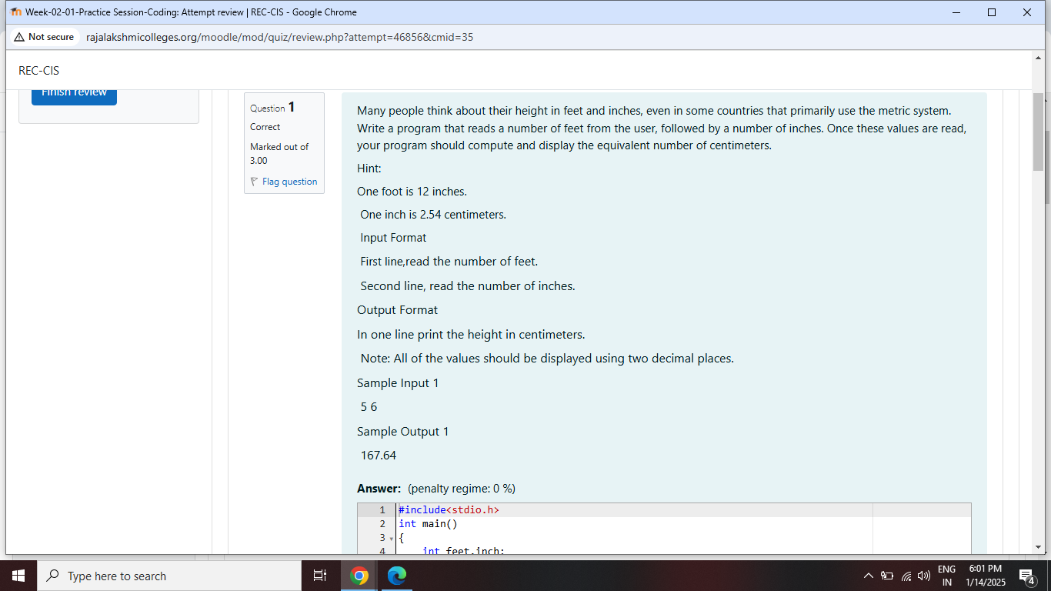

# Problem:

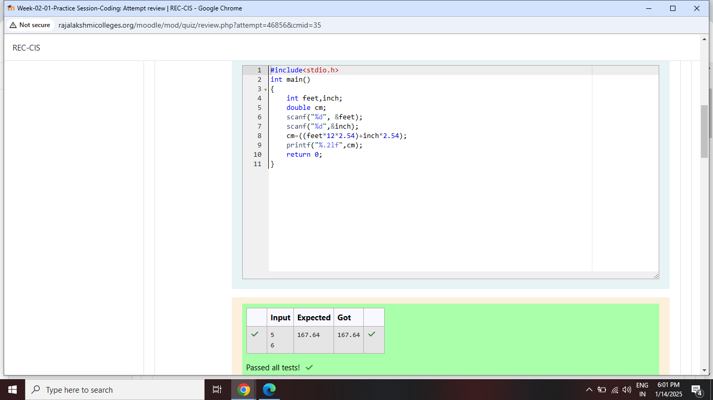

# Question 02:

# 

# Problem:

# 

# Question 03:

# 

# Problem:

# 

# Question 04:

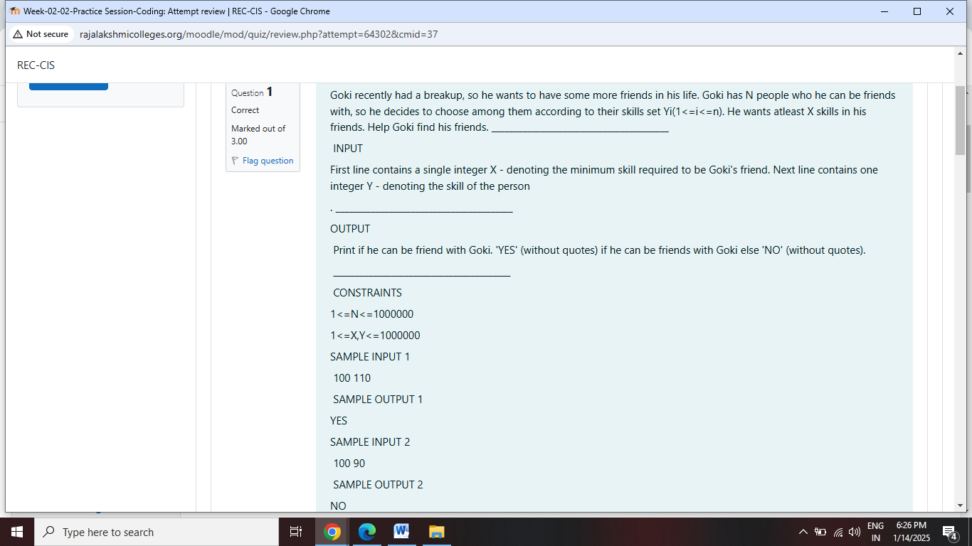

# Problem:

# 

# Question 05:

# 

# Problem:

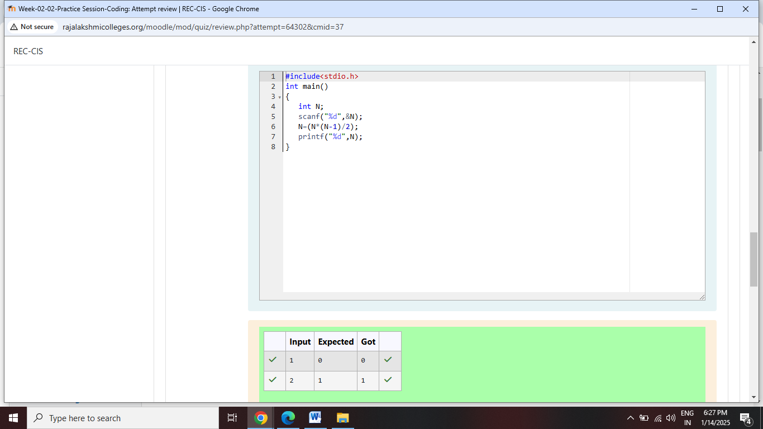

# Question 06:

# 

# Problem:

# 